Appendix 'C'

Adult Social Care Policies and Procedures

WELLBEING PRINCIPLE

WARNING! Please note if the review date shown below has passed this procedure may no longer be current and you should check the PPG E Library for the most up to date version

WELLBEING PRINCIPLE

WARNING! Please note if the review date shown below has passed this procedure may no longer be current and you should check the PPG E Library for the most up to date version

WELLBEING PRINCIPLE

WARNING! Please note if the review date shown below has passed this procedure may no longer be current and you should check the PPG E Library for the most up to date version

WELLBEING PRINCIPLE

WARNING! Please note if the review date shown below has passed this procedure may no longer be current and you should check the PPG E Library for the most up to date version

WELLBEING PRINCIPLE

WARNING! Please note if the review date shown below has passed this procedure may no longer be current and you should check the PPG E Library for the most up to date version

WELLBEING PRINCIPLE

WARNING! Please note if the review date shown below has passed this procedure may no longer be current and you should check the PPG E Library for the most up to date version

WELLBEING PRINCIPLE

WARNING! Please note if the review date shown below has passed this procedure may no longer be current and you should check the PPG E Library for the most up to date version

WELLBEING PRINCIPLE

WARNING! Please note if the review date shown below has passed this procedure may no longer be current and you should check the PPG E Library for the most up to date version

WELLBEING PRINCIPLE

WARNING! Please note if the review date shown below has passed this procedure may no longer be current and you should check the PPG E Library for the most up to date version

WELLBEING PRINCIPLE

WARNING! Please note if the review date shown below has passed this procedure may no longer be current and you should check the PPG E Library for the most up to date version

WELLBEING PRINCIPLE

WARNING! Please note if the review date shown below has passed this procedure may no longer be current and you should check the PPG E Library for the most up to date version

WELLBEING PRINCIPLE

WARNING! Please note if the review date shown below has passed this procedure may no longer be current and you should check the PPG E Library for the most up to date version

WELLBEING PRINCIPLE

WARNING! Please note if the review date shown below has passed this procedure may no longer be current and you should check the PPG E Library for the most up to date version

WELLBEING PRINCIPLE

WARNING! Please note if the review date shown below has passed this procedure may no longer be current and you should check the PPG E Library for the most up to date version

WELLBEING PRINCIPLE

WARNING! Please note if the review date shown below has passed this procedure may no longer be current and you should check the PPG E Library for the most up to date version

WELLBEING PRINCIPLE

WARNING! Please note if the review date shown below has passed this procedure may no longer be current and you should check the PPG E Library for the most up to date version

Contents

WELLBEING PRINCIPLE 1

POLICY VERSION CONTROL 2

1. POLICY STATEMENT 3

2. KEY DEFINITIONS AND PRINCIPLES APPLICABLE TO THIS POLICY 5

2.1 Wellbeing: 5

2.2 Assessment: 5

2.3 Needs: 5

3. STATEMENT OF INTENT 6

3.1 Promoting wellbeing in Lancashire 6

3.2 Additional Key Principles and Standards 7

4 FLOW CHARTS / DIAGRAMS OR EXAMPLES 9

5 DOCUMENT HISTORY 10

POLICY VERSION CONTROL
POLICY NAME | Wellbeing Principle
Document Description | This document sets out the Council’s broad responsibilities for wellbeing to a specific individual or wider community in Lancashire when undertaking any of its functions relating to the Care Act 2014
Document Owner
- Officer, position and contact details
Document Author | Linda Thomas | Date | 29 October 2015
Status  (Draft/Live/Withdrawn) | Draft | Version | 0.3
Last Review Date |  | Next Review Due date
Approved by | Tony Pounder | Position | Director of Adult Services
Signed |  | Date Approved

DOCUMENT CHANGE HISTORY
Version No | Date | Issues by | Reason for change

POLICY STATEMENT
The Care Act 2014 introduced the Core Principle that Local authorities must promote wellbeing when carrying out any of their care and support functions in respect of a person. This may sometimes be referred to as “the wellbeing principle”.

Although the wellbeing principle applies specifically when the local authority performs an activity or task, or makes a decision, in relation to a person, the principle should also be considered by the local authority when it undertakes broader, strategic functions, such as planning, which are not in relation to one individual. As such, “wellbeing” should be seen as the common theme around which care and support is built at local and national level.

The wellbeing principle applies equally to those who do not have eligible needs but come into contact with the health and social care agencies in some other way (for example, via an assessment that does not lead to ongoing care and support) as it does to those who go on to receive care and support, and have an ongoing relationship with the local authority. It should inform the delivery of universal services for example shopping delivery services, community centre, which are provided to all people in the local population, as well as being considered when meeting eligible needs.

The wellbeing principle applies in all cases where a local authority is carrying out a care and support function, or making a decision, in relation to a person. It applies equally to adults with care and support needs and their carers.

In some specific circumstances, it also applies to children, their carers and to young carers when they are subject to transition assessments.

Neither the principles, nor the requirement to promote wellbeing, require the local authority to undertake any particular action. The steps a local authority should take will depend entirely on the circumstances. The principles as a whole are not intended to specify the activities which should take place. Instead, their purpose is to set common expectations for how local authorities should approach and engage with people.

Therefore to fulfil its duty under section 1 of the Care Act, the Council will apply the 'wellbeing principle', working with its statutory, voluntary and private sector partners, when carrying out a care and support function, or making a decision that is relevant, coherent, timely and sufficient.

The 'principle' will apply to the whole population of Lancashire and not just those with care and support needs or in some other way already known to the system, and delivered in ways that are accessible. Lancashire will make all reasonable adjustments to ensure that all disabled people have equal access in line with the Equality Act 2010.

The geography and population of Lancashire is diverse and our Adult Social Care Policies and practice will aim to deliver services and supports that are representative of the communities in which we work.

The Council will follow the Care Act and other relevant legislation, policies and guidance to ensure our practice is of high quality and legally compliant. Where our customers or those we come into contact with wish to challenge or raise concerns in regard to our decisions, regarding the 'wellbeing principle' the Council's complaints procedures will be made available and accessible.

KEY DEFINITIONS AND PRINCIPLES APPLICABLE TO THIS POLICY

2.1 Wellbeing:
“Wellbeing” is a broad concept, and it is described as relating to the following areas in particular:

- personal dignity (including treatment of the individual with respect)
- physical and mental health and emotional wellbeing
- protection from abuse and neglect
- control by the individual over day-to-day life (including over care and support provided and the way it is provided)
- participation in work, education, training or recreation
- social and economic wellbeing
- domestic, family and personal
- suitability of living accommodation
- the individual’s contribution to society

There is no hierarchy, and all should be considered of equal importance when considering “wellbeing” in the round.

2.2 Assessment:
This is one of the key interactions between a local authority and an individual. The process must be person-centred throughout, involving the person and supporting them to have choice and control. It starts from when a local authority begins to collect information about the person, and will be an integral part of the person’s journey through the care and support system as their needs change. An assessment must seek to establish the total extent of needs before the local authority considers the person’s eligibility for care and support and what types of care and support can help to meet those needs.

A carer can also have an assessment.

2.3 Needs:
A person’s needs are specific to them, these can include help and support required by the individual due to illness, disability, old age that enables them to live more independently. There are many ways in which needs can be met, behind the Care Act is the intention to encourage diversity rather than point to a service or solution that is neither best for nor what the person wants.

STATEMENT OF INTENT
When undertaking any care or support functions, the Council workers will ensure they consider an individual's wellbeing and acknowledging that the individual themselves is considered to be best placed to judge their own wellbeing. Therefore the following will be considered when undertaking interactions with any individuals.

3.1 Promoting wellbeing in Lancashire
When undertaking their work Council workers will consider how to promote wellbeing. This will involve actively seeking improvements in the aspects of wellbeing when carrying out a care and support function in relation to an individual, at any stage of the process, from the provision of information and advice to reviewing a care and support plan.

Wellbeing covers the broad range of people's lives and will take account of a wide variety of specific considerations depending on the individual.

The Council can promote a person’s wellbeing in many ways. This will be dependent on the circumstances, including the person’s needs, goals and wishes, and how these impact on their wellbeing. The Care Act has not set a specific approach, as it advocates that a local authority should consider each case on its own merits, consider what the person wants to achieve, and how the action which the local authority is taking may affect the wellbeing of the individual.

In individual cases, it is likely that some aspects of wellbeing will be more relevant to the person than others. For example, for some people the ability to engage in work or education will be a more important outcome than for others, and in these cases “promoting their wellbeing” effectively may mean taking particular consideration of this aspect. The Council will adopt a flexible approach that allows for a focus on which aspects of wellbeing matter most to the individual concerned.

During the assessment process, for instance, the Council will explicitly consider the most relevant aspects of wellbeing to the individual concerned, and assess how their needs impact on them. Taking this approach will allow for the assessment to identify how care and support, or other services or resources in the local community, could help the person to achieve their outcomes.

During care and support planning, when agreeing how needs are to be met, promoting the person’s wellbeing may mean making decisions about particular types or locations of care (for instance, to be closer to family).

3.2 Additional Key Principles and Standards
In addition to the general principle of promoting wellbeing, there are a number of other key principles and standards which the Council must have regard to when carrying out the same activities or functions:
- make the assumption that the individual is best-placed to judge their own wellbeing. Building on the principles of the Mental Capacity Act, the Council will assume that the person themselves knows best their own outcomes, goals and wellbeing. The Council will not make assumptions as to what matters most to the person;

- ensure the individual’s views, wishes, feelings and beliefs are central. Considering the person’s views and wishes is critical to a person-centred system. The Council will not ignore or downplay the importance of a person’s own opinions in relation to their life and their care. Where particular views, feelings or beliefs (including religious beliefs) impact on the choices that a person may wish to make about their care, these will be taken into account. This is especially important where a person has expressed views in the past, but no longer has capacity to make decisions themselves;

- the importance of preventing or delaying the development of needs for care and support and the importance of reducing needs that already exist. At every interaction with a person, the Council will consider whether or how the person’s needs could be reduced or other needs could be delayed from arising. Effective interventions at the right time can stop needs from escalating, and help people maintain their independence for longer;

- the need to ensure that decisions are made having regard to all the individual’s circumstances (and are not based only on their age or appearance, any condition they have, or any aspect of their behaviour which might lead others to make unjustified assumptions about their wellbeing). The Council will not make judgments based on preconceptions about the person’s circumstances, but will in every case work to understand their individual needs and goals;

- the importance of the individual participating as fully as possible in decisions about them and being provided with the information and support necessary to enable the individual to participate. Care and support should be personal, and Council workers should not make decisions from which the person is excluded;

- the importance of achieving a balance between the individual’s wellbeing and that of any friends or relatives who are involved in caring for the individual. People should be considered in the context of their families and support networks, not just as isolated individuals with needs. Council workers should take into account the impact of an individual’s need on those who support them, and take steps to help others access information or support;

- the need to protect people from abuse and neglect. In any activity which the Council undertakes, it will consider how to ensure that the person is and remains protected from abuse or neglect. This is not confined only to safeguarding issues, but should be a general principle applied in every case;

- the need to ensure that any restriction on the individual’s rights or freedom of action that is involved in the exercise of the function is kept to the minimum necessary for achieving the purpose for which the function is being exercised. Where the Council has to take actions which restrict rights or freedoms, they will ensure that the course followed is the least restrictive necessary.

Considering these matters should lead to an approach that looks at a person’s life in the round, considering their needs in the context of their skills, ambitions, and priorities, as well as the other people in their life and how they can support the person in meeting the outcomes they want to achieve. The focus should be on supporting people to live as independently as possible for as long as possible.

FLOW CHARTS / DIAGRAMS OR EXAMPLES

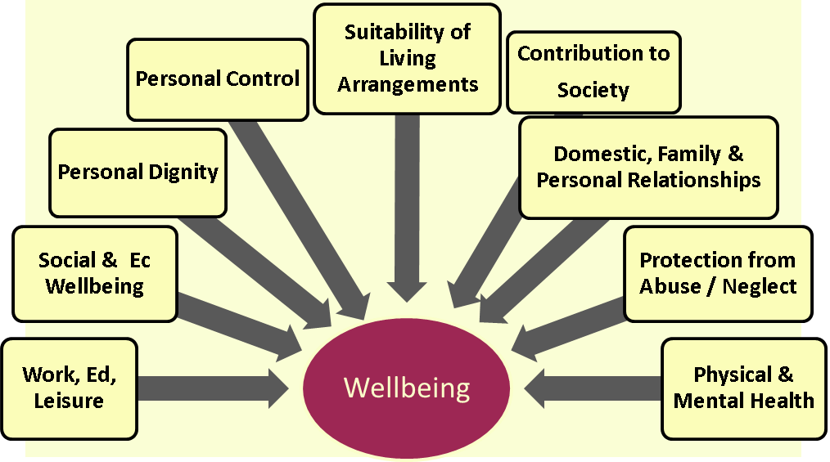

DOCUMENT HISTORY

RELATED DOCUMENTS
OTHER RELATED DOCUMENTS | - Needs Assessment Policy  - Eligibility Criteria Policy  - Independent advocacy Policy  - Care and Support Planning Policy  - Direct Payments policy  - Transitions from Children's Services to Adult Services Policy  - Ordinary Residence Policy  - Continuity of Care Policy
LEGISLATION OR OTHER STATUTORY REGULATIONS | - Care Act Section1  - Chapter 1 Promoting Wellbeing Statutory Guidance  - Chapter 3 Information and advice Statutory Guidance  - Chapter 5 Managing provider failure Statutory Guidance  - Chapter 6 Assessment and eligibility Statutory Guidance  - Chapter 7 Independent advocacy Statutory Guidance  - Chapter 10 Care and support planning Statutory Guidance  - Chapter 12 Direct payments Statutory Guidance  - Chapter 13 Review of care and support plans Statutory Guidance  - Chapters 14 Safeguarding Statutory Guidance  - Chapter 16 Transition to adult care and support Statutory Guidance  - Chapter 19 Ordinary residence Statutory Guidance  - Chapter 20 Continuity of care Statutory Guidance

